Trigonometry/Precalculus Name
6.3 Vector Combination in Component Form Date
Day _______ Block

1) Two soccer players kick a soccer ball at the same time, one with a force of 50 N at a direction angle of 30 degrees and another with a force of 40 N at a direction angle of 100 degrees. (in standard position)
a. Sketch and label a picture of each vector. | b. Write the force vectors in component form.
c) What is the magnitude of the combined forces? | d) What is the direction angle of the resultant vector?
2) A commercial jet is flying from San Diego to Washington D.C.. The jet’s velocity with respect to the air is 575 miles per hour with a direction angle of 50 degrees. The wind is blowing towards the east with a velocity of 45 mph.
a. Draw a picture. | b. Write the velocity of the wind and the plane  as vectors in component form.
c) What is the speed of the jet with respect to the ground? | d) What is the direction of the jet? (in bearing form)

3) Choose the figure that corresponds with the best response. Explain why you chose your answer.
a)
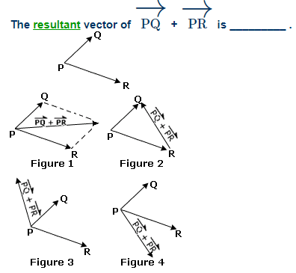  b) | 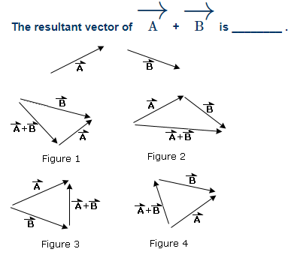

4a) Two forces of 10 kg and 24 kg act on an object at right angles. Find the resultant force.

b) Find the direction angle of the force.

