Trigonometry/Precalculus Name
Algebra Review Date
Day _________ HW Block
Solve each equation, if possible, using any strategy. Be sure to check your solutions.
1) 2)
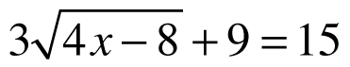
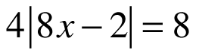

3) 4)
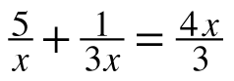
(2y – 3)(y – 2) = –12y + 18

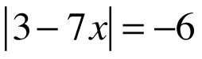
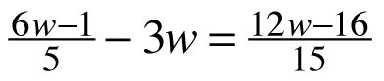
5) 6)

 | 7) (x – 3)² – 2 = 14 | 8) (x + 2)² + 4(x + 2) – 5 = 0

Write a linear equation for each of the following. Leave your answer in slope-intercept form.
(y = mx + b)
9) a line with slope 1/2 though ( 8, -2) 10) a line that passes through ( 1, -8) and (6, -3)

11) a line perpendicular to y = -3x + 8 12) a line parallel to y = 2/3 x – 15 through
that passes through (-9, 12) that passes through (6, 2).

Write the trigonometric equation you would use to solve for the missing sides in the following triangles. Then solve for each.
13) 14)
