**Trigonometry/Precalculus Name**

**Chapter 5 Review Date**

**Day ______ Block**

**1)** At a county fair, the Ferris wheel has a diameter of 32m and its center is 18 m above the ground. The wheel completes one revolution every 30 seconds.

**a)** Graph a rider’s height above the ground, in meters, versus the time in seconds. Assume the rider begins at the lowest position on the wheel.

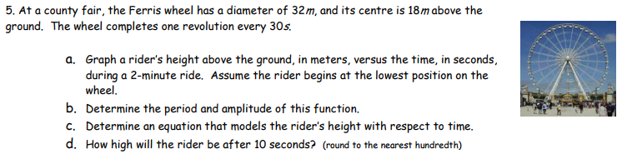

**b)** Write an equation that models the rider’s height with respect to time.

**2)** At the high tide the water level at a particular boat dock is 9 feet deep. At low tide the water is 3 feet deep. On a certain day the low tide occurs at 3 AM and high tide occurs at 9AM.

The equation to model the tide height (y) with respect to hours after midnight (x) is given below.



|  |  |
| --- | --- |
| **a)** Using this data, sketch a sinusoidal curve to model the tides height throughout the day. | **b)** What is the water level at 2 PM? |

**C)** Find the first and second time after midnight that the water reaches a level of 5 feet.

3) Write an equation for the sinusoidal function that passes through and .

4) Simplify each of the following using trigonometric identities.

|  |  |  |
| --- | --- | --- |
| a)  Screen Clipping | b)  Screen Clipping | c)  Screen Clipping |

5) Verify each of the following identities:

|  |  |
| --- | --- |
| a) sin x ( cot x + tan x) = sec x | b) sin (x + y) – sin (x – y) = 2cos x sin y |

c) d)

Screen Clipping Screen Clipping

**6)** Solve each of the following equation for the given intervals.

**a) ** for all values of x **b) ** for [0, 2π)

**c) ** for all values of x  **d) ** for [0, 2π)

**e) ** for all values of x **f) ** for [0, 2π)

Use sum and difference identities to find the exact value of the following:

**7)  8)  9) **

If  and , find the exact value for each of the following:

**10) sin u 11) sin 2u**

**12) cos 2u 13) tan 2u**

**14)  15) **

Use trig identities to write each expression as the sine, cosine or tangent of one angle.

**16)**  **17)**  **18)** 

Find the solutions to the following equations on the interval [0, 2π).

|  |  |
| --- | --- |
| **19)**  **Screen Clipping** | **20)**  **Screen Clipping** |