Precalculus Name

Critical Points and Polynomial Behavior Date

Day _____ Block

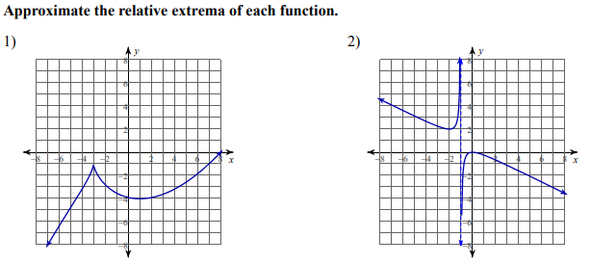

|  |  |
| --- | --- |
| Relative Minimum: _________  Relative Maximum:_________ | Relative Minimum: _________  Relative Maximum:_________ |

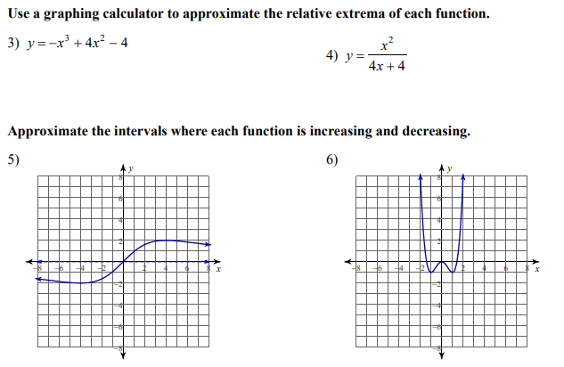

|  |  |
| --- | --- |
| Relative Minimum: _________  Relative Maximum:_________ | Relative Minimum: _________  Relative Maximum:_________ |



|  |  |
| --- | --- |
| Interval of increase:  Interval of decrease: | Interval of increase:  Interval of decrease: |

|  |  |
| --- | --- |
| 7) Determine the intervals of concavity for the function below: | 8) Estimate the point(s) of inflection for the function. |

Use each of the following graphs to determine the indicated information:

|  |  |
| --- | --- |
| 9) Relative minimum: ( , )  Relative maximum: ( , )  Interval of increase:  Interval of decrease:  Interval function is concave up:  Interval function is concave down:  Coordinates for point(s) of inflection: | y = x3 - 3x2 + 4 |
| 10) Relative minimum:  Relative maximum:  Interval of increase:  Interval of decrease:  Interval function is concave up:  Interval function is concave down:  Coordinates for point(s) of inflection: | y = (x+1)2(x -2)3 |

Precalculus Name

Finding Polynomial Roots & End Behavior Practice Date

Day _____ Block

Use the graph of the polynomial to determine **a)** if the degree is even or odd, **b)** if the leading coefficient is positive or negative, **c)** all the real zeros and d) the end behavior.

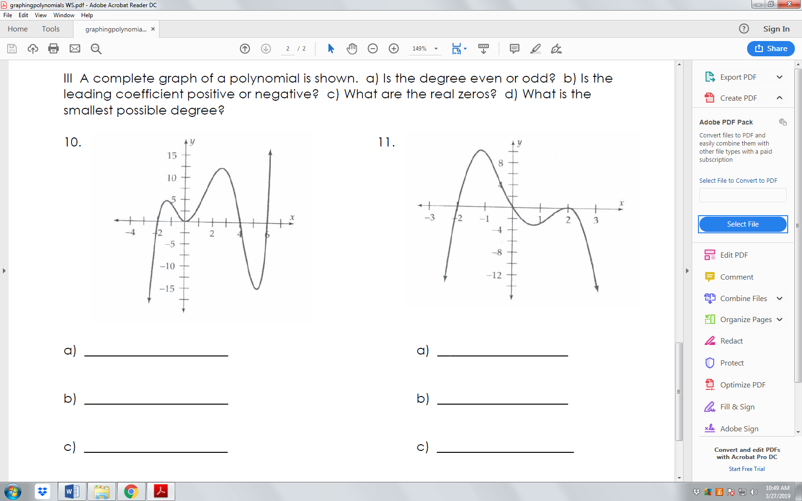**1)** **2)**

**a)**   **a)**

**b)**   **b)**

**c)**   **c)**

**d) ____________________________ d)____________________________**

Describe the end behavior for each of the following functions.

**3)**  **4)**  **5)** 

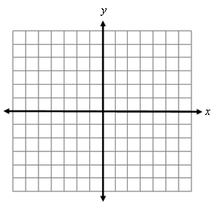**6)** Sketch the graph of the equation with a double

root at -2, a single root at 5, a triple root at 0, a double

root at 2 and a degree of 6.

Factor the polynomial to find the *x*-intercepts, find the *y*-intercept, consider end behavior and multiplicities, and then sketch the graph of the polynomial function.

**7)  8) **

Use a graphing utility to find a real root, then find the remaining real roots of the polynomial using synthetic division, factoring, or the quadratic formula. Sketch the graph of the polynomial function. (include the y-intercept)

**9)** *f(x)* = x5 -6x3 – 36x **10) **