6.2 Law of Cosines Notes

Law of Cosines

-used to solve oblique triangles when ________________________ will not work.

Use… | when given…
Law of  Sines | 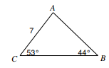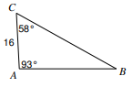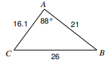
Law of  Cosines | 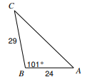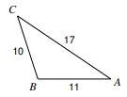

Law of Cosines Formula

Ex 1: Find the m<A.

Ex 2: Find AB.
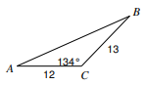

Trigonometry/Precalculus Name
Law of Cosines CW Date
Day _____ Block

Use the Law of Cosines to find the measure of the missing side or angle.

1) Find the length of BC 2) Find m<C
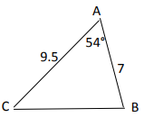 | 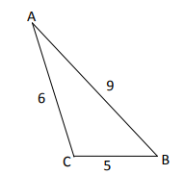

3) Find AB. 4) Find m < B.
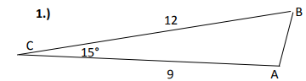 | 