Trigonometry/Precalculus Name
The Ambiguous Case of the Law of Sines Date
Day ______ Block

The following triangles can be drawn 2 possible ways. Draw a sketch of both possibilities, then find the missing sides and angle measures for each pair of triangles.
1) m <A = 43^{ᵒ}, c = 32 ft, a = 31 ft
B B

A C A C

2) m <C = 16^{ᵒ}, b = 22 mi, c = 11 mi

3)

4) How can you determine whether or not it is possible for the given dimensions of a triangle to form two different triangles given only an angle and two sides (SSA)?

Use any method to show that forming a triangle with the following sets of angles and sides is not possible.
5) 6)

Review
7) Find the measure of each missing angle.  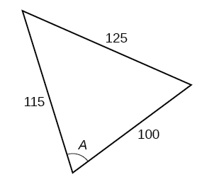 | 8)  A scientist working on nature preservation needs to calculate the length of a lake from one side to the point furthest across. Using the measurements she is able to make, find the length of the lake.  