Name

Parent Graphs

Make a careful graph of each of the following functions.

Equation:  Equation: 

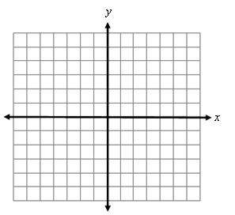Name Name

*x y*

-2

-1

0

1

2

*x y*

-2

-1

0

1

2

Equation:  Equation: 

Name Name

*x y*



-1

0

1/2

1

2

*x y*

-1

0

1

2

3

Equation:  Equation: 

Name Name

*x y*

0

1

4

9

*x y*

-3

-2

-1

0

1

2

3