Trigonometry/Precalculus Name

Radians, Degrees, & Coterminal Angles Date

Day ______ Block

Convert each of the following degree measurements to radians. Always simplify.

|  |  |  |
| --- | --- | --- |
| 1) 30ᵒ | 2) 45ᵒ | 3) 60ᵒ |
| 4) 210ᵒ | 5) 315ᵒ | 6) 120ᵒ |

Convert each of the following radian measurements to degrees. Simplify.

|  |  |  |
| --- | --- | --- |
| 7) | 8) | 9) |
| 10) | 11) | 12) |

Name a negative and positive angle coterminal with the angles given below.

|  |  |  |
| --- | --- | --- |
| 13) 150ᵒ | 14) 135ᵒ | 15) 330ᵒ |
| 16) | 17) | 18) |

Write an equation for each of the graphs below.

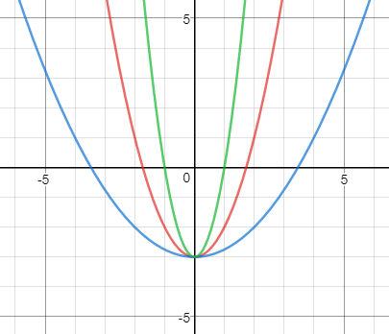

Write an equation for each of the graphs below.



Write an equation for each of the graphs below.

