Solving Trigonometric Equations Notes

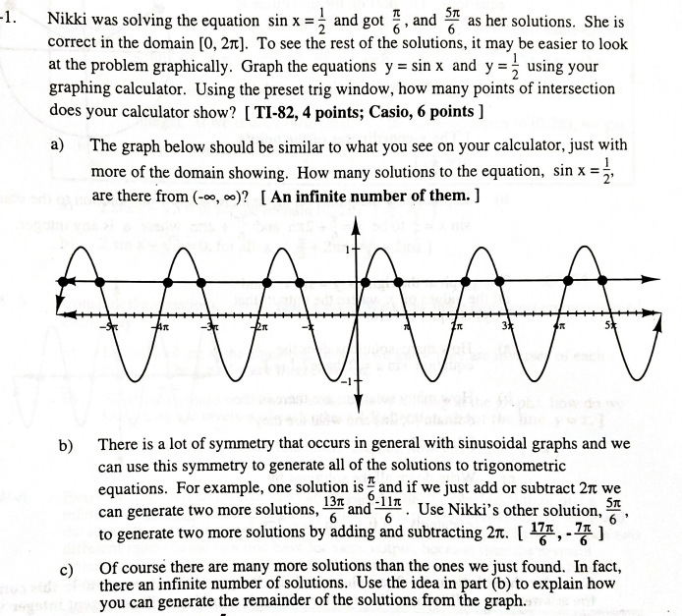

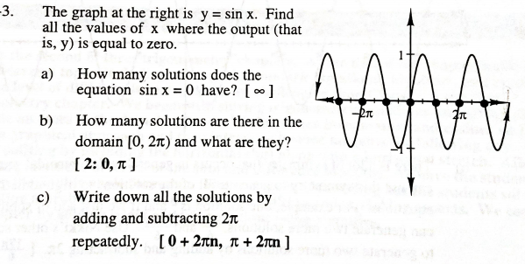

Example: Solve for x in the indicated domain. When no domain is given, find all values of x.

a) $2\sin{x- \sqrt{3}=0 , for the domain \left[0, 2π\right]}$ b) $2\sin{x- \sqrt{3}=0 , for all x}$

c) $(\sin{x+ 1)(2\cos{x-1) }=0 , for the domain \left[0, 2π\right]}$ d) $(\sin{x+ 1)(2\cos{x-1) }=0 }$

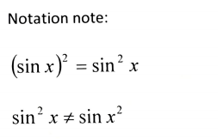

e)





f)

Trigonometry/Precalculus Name

Solving Trigonometric Equations Date

Day ________ Block

Solve for the unknown variable on the interval .

1)  2) 

3)  4) 

Solve for the unknown variable for all values of x.

5)  6) 

7)  8) 