Trigonometry/Precalculus Name
More Special Right Triangle/Rationalizing Denominators Practice Date
Day ______ Block

Use the rules of Special Right Triangles to calculate the missing side of each triangle.
1)  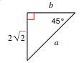 | 2)  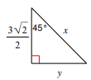
3)  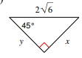 | 4)  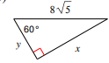
Rationalize each of the following denominators.
5)  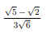 | 6)  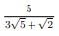
7)  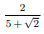 | 8)  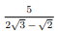
9)  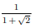 | 10)  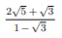

Write an equation of a line for each of the following: (leave your answer in y = mx + b )
11) a line with slope = ½ that passes through (14,5 ).

12) a line with y-intercept = (0,9) that passes through (20, 4) .

13) a line with slope = -2/3 that passes through (9, 7).

14) While working on the “dedicated fan” problem, a student calculates a slope of .14 for their line of best fit. If the x axis represents the distance from the football field, and the y axis represents the field (width) of vision, what does the slope of the line represent? Explain your answer.

