**Trigonometry/Precalculus Name**

**Special Right Triangle/Rationalizing Denominators Date**

**Day _________ Block**

Use the idea of special right triangles below to find the missing sides of each triangle.

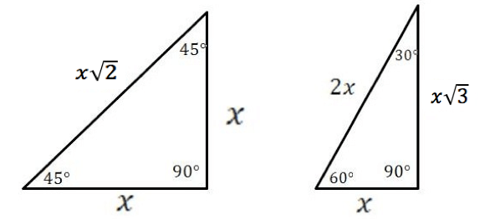

|  |  |
| --- | --- |
| 1)  Screen Clipping | 2)  Related image |
|  |  |
| 5)  Image result for special right triangles worksheet with hypotenuse 1 | 6)  Related image |
|  | 7) Solve for a, b, c and d.  a =  b =  c =  d = |

Simply each of the following expressions by rationalizing each denominator.

|  |  |
| --- | --- |
| 8) $\frac{1}{√2}$ | 9) - $\frac{2}{√3}$ |
| 10) | 11) |
|  | 13) |
|  |  |

Convert the following measures from degrees to radians.

11) 300ᵒ 12) -120ᵒ

Convert the following from radians to degrees.

13)  14) 

Find a coterminal angle to each of the following angle measures:

15) -120ᵒ 16)  17) 

Write a trigonometric ratio and find the missing angles for each of the following right triangles:

|  |  |
| --- | --- |
| 18)  Screen Clipping | 19)  Image result for inverse sine and cosine right triangle worksheet 45 45 90 |
| 20)  7 | 21)  Image result for inverse sine and cosine right triangle worksheet |