Trigonometry/Precalculus Name

Transforming Functions Date

Day ______ Block

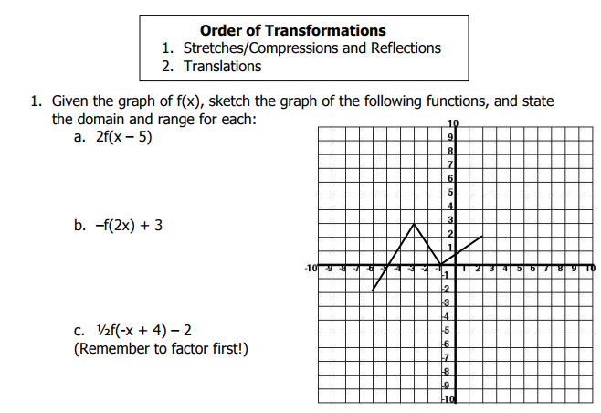

1. -f(x) + 3
2. 2f(x-5)
3. ½ f(x + 4) -2

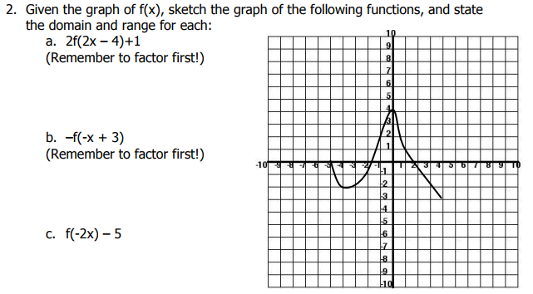

1. f(x) – 5
2. -f( x – 4 )
3. 2f(x)

3. Sketch both the parent graph and its transformed function. State the domain and range for the function after its transformation.

a)   b)  

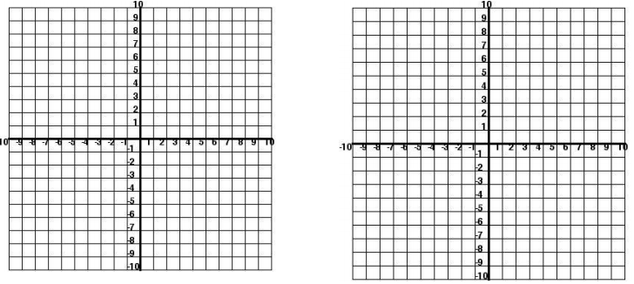

4) Write an equation for each of the following transformed functions. Write the domain and range for each function.

a) b)

|  |  |
| --- | --- |
| Screen Clipping | Screen Clipping |

c)

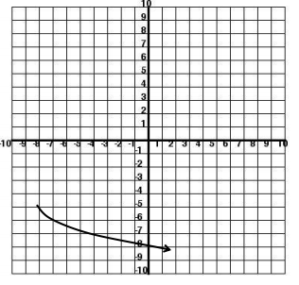

Precalculus Name

Transforming Parent Graph Functions Date

Day ______ Block

expand vertically by a factor of 2,

translate right 1 unit.

compress vertically by a factor of ½,

translate left 3 units

